PARKING VINCI
CONFIGURATION
PLAN ARCHITECTURAL
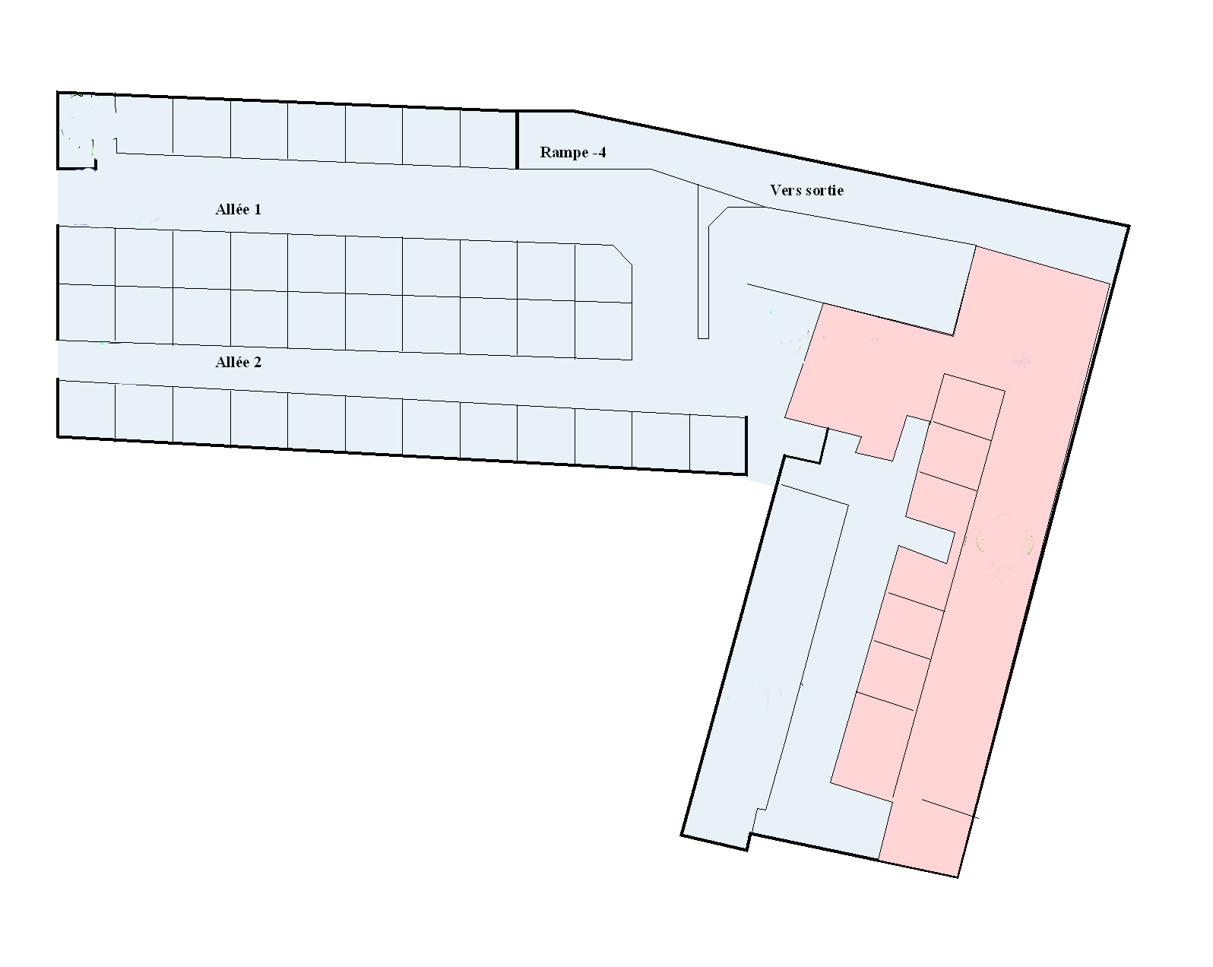
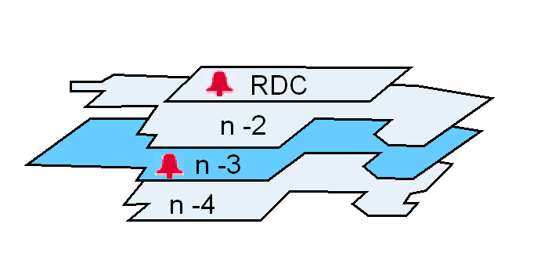
Configuration générale du parking
Parking : Zone 31

